LOUISIANA BOARD OF PROFESSIONAL GEOSCIENTISTS
1800 City Farm Drive, Building 5B, Baton Rouge, LA 70806

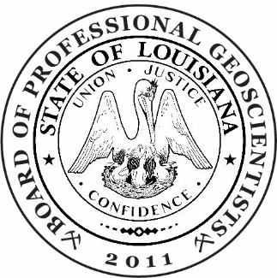

REGULAR MEETING OF LBOPG
Wednesday, March 11, 2026, 1:00 p.m.
1800 City Farm Drive
Building 5B
Baton Rouge, Louisiana 70806
Also
Virtual Meeting on Zoom
(See website LBOPG.org for invitation details)

AGENDA (*Motion required)
1. Call to Order
2. Roll Call
3. Public Comments
4. Request for License Application Fee Refund (Joseph Houk)*
5. Review and approval of the minutes of the meeting held on January 14, 2025*
6. Treasurer’s report*
a. Regular report for period including July 2025 – February 2026
7. Reports from Standing Committees – Activities and Goals:
  - Application Review (Stiegler, Chair)
- Recommendation of candidates for license and testing*
  - License Examination (Williamson, Chair)
  - Compliance (Schramm, Chair)
- Report on 2026 Continuing Education Audits
  - Outreach (Culpepper, Chair)
- Report on ASBOG 2025 Annual meeting in Salt Lake City, UT
- Continued discussion of survey questions to licensees
- Continued discussion of Geo poll
  - Strategic Five-year Plan & Rules Review Ad Hoc (McDade, Chair)
  - Office (Macon; McCreary; Meaux; Dennis)
- Progress of search committee for executive secretary position
- Website public information page
- Reminders

8. Old Business
- Continued discussion to augment legal counsel with assistance outside the Louisiana Office of the Attorney General
- Consideration of draft resolution (as required by LDOJ) to hire outside legal counsel for issues related to complaints and other outstanding legal concerns
- EXECUTIVE SESSION request: To discuss personnel issues related to overtime; also, to discuss complaint submitted in June 2025 for which no legal counsel was available
8. New Business
- Discussion regarding acceptance of the draft agreement with the Louisiana Department of Justice for board participation during FY 2026-2027 in the Occupational Licensing Review Program
- Discussion to consider endorsing Chase Cromwell as an outside Subject Matter Expert (SME) with the ASBOG Council of Experts (ASBOG makes this decision independently of the board, but board endorsement may be helpful.)
- Discussion to consider assisting the New Orleans Geological Society (NOGS) in reviewing curriculum from Tulane University, volunteered by that university, to ascertain the percent of geological content in their earth sciences courses (Tulane Department of Earth & Environmental Science)
9. Next regular meeting date, time, and location: Wednesday, May 13, 2026, at 1 pm; location to be determined; also on Zoom
10. Adjourn*

